Ivica Smokovski
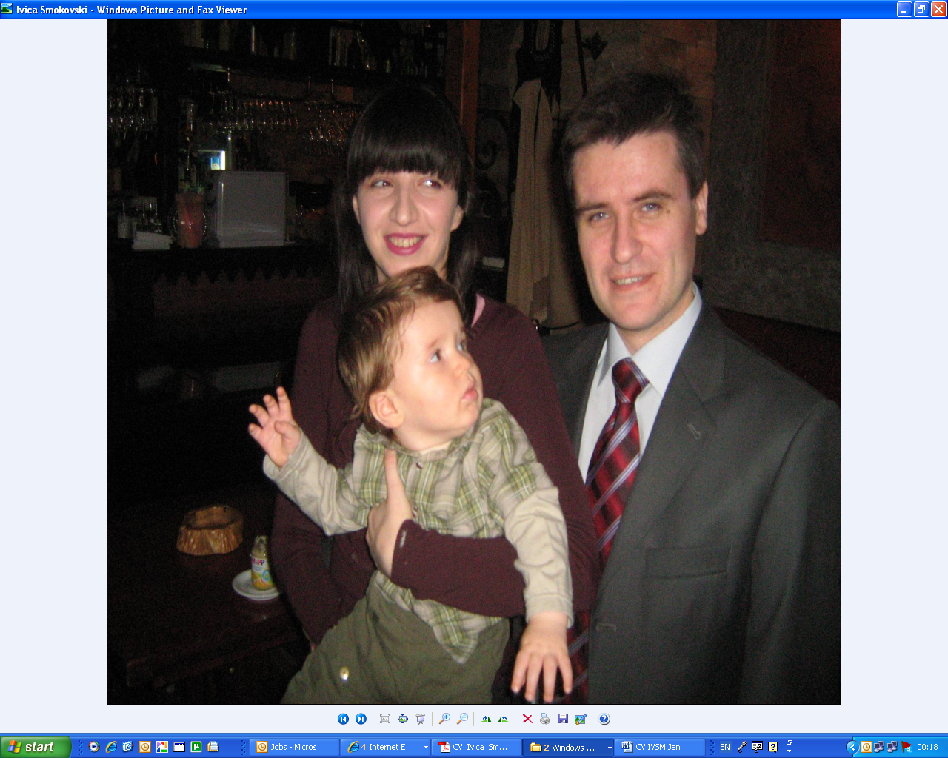
personal
address: bul. ASNOM 34-3/4, MK-1000 Skopje
e-mail: ivica.smokovski@gmail.com;
ivica.smokovski@zdravstvo.gov.mk
mobile: +389 71 206 848
D/POB: 13-Oct-1974, Skopje, MK

education
Sep 89 – Jun 93 |  |  | High School Rade Jovceski Korcagin, Skopje, MK  Average: 5.0 of 5.0; awarded as best student in the generation
Oct 93 - Jul 99 |  |  | Doctor of Medicine (MD)  Medical Faculty Skopje, MK  Average: 9.7 of 10.0 (second highest in generation)
Mar 04 - Feb 08 |  |  | Specialist of Internal Medicine  Medical Faculty Skopje, MK  Final exam completed on 12-Jan-2009
Mar 16 - |  |  | Fellow in Endocrinology, Diabetes and Metabolic Disorders  Medical Faculty Skopje, MK
Oct 01 - Jun 07 |  |  | Master of Medical Sciences (mr.sci.med.)  Internal medicine (cardiology-diabetes), Medical Faculty Skopje, MK  Average: 10.0 of 10.0  Thesis: Comparison of UKPDS and Framingham model for absolute risk assessment of coronary heart disease in type 2 diabetes and clinical implications of their use
Sep 11 – Apr 14 |  |  | Doctor of Medical sciences (dr.sci.med./PhD)  Internal medicine (Endocrinology), Medical Faculty Skopje, MK  Thesis: Precision of United Kingdom Prospective Diabetes Study model in prediction of coronary artery disease risk in type 2 diabetes patients from Republic of Macedonia
Jan 02 – Nov 03 |  |  | Certificate of Applied and Basic Course for Clinical Research and GCP Brookwood International Academy of Healthcare Research, Guildford, UK  Scores: 4.47 of 5.00 for Applied; and 5.00 of 5.00 for Basic module
working experience
Jun 16 - |  |  | University Clinic of Endocrinology, Diabetes and Metabolic Disorders Skopje  Department of Diabetes
Sep 13 - |  |  | Faculty of Medical Sciences, University Goce Delcev Stip  Jan-16 to date Associate Professor (Doc.)  Sep 13 - Dec 15 Assistant Professor
Jan 14 – May 16 |  |  | University Clinic of Toxicology and Emergency Internal Medicine Skopje  Department of Emergency Internal Medicine
Jul 12 – Jun 16 |  |  | Medical Advisor in the Cabinet of Minister, Ministry of Health of Republic of Macedonia  Involved in national healthcare policy making, numerous projects related to training and education of medical specialists, diabetes care, rational use of medicines, introduction of neonatal cardio-surgery, introduction of strategic planning and Balanced Score Cards in public healthcare institutions, introduction of US-MK Exchange Physician Program, etc
Nov 11 – Jun 12 |  |  | Private HealthCare Institution Smokovski
Nov 01 – Oct 11 |  |  | Specialist of Internal Medicine in Out-patient Clinic  Novo Nordisk Macedonia
 |  |  | Regional Medical Advisor, Diabetes
Jan 01 – Oct 01 |  |  | Army of Republic of Macedonia, Military Hospital at Skopje Airport | Service as GP in Military Hospital at Skopje Airport
 |  |  | Service as GP in Military Hospital at Skopje Airport
Sep 99 - Jan 01 |  |  | Alkaloid AD Skopje
 |  |  | Project Leader, Regulatory Affairs, Post-marketing Studies
May 99 - Jun 99 |  |  | Participation in the joint project of UNHCR and 'Action Against Hunger' assessing the living conditions of Kosovo refugees and nutritional status of their children, Refugee camps, MK
Aug 98 |  |  | Clerkship at the Department of Internal Medicine-Cardiology (Medical Candidate), Helsinki University Hospital, Helsinki, FI
Feb 98 - Feb 99 |  |  | Member of Scientific and Educational Board as Students' representative, Medical Faculty Skopje, MK
Aug 97 |  |  | Voluntary work with mentally disabled children and elderly, Mariaberg, DE
Jul 97 |  |  | Clerkship at the Department of Cardiology (Medical Candidate), Dokuz Eylul University Hospital, Izmir, TR
languages

- English
- German
- Southern Slavic languages
relevant memberships

- National Diabetes Committee
- EPMA (European Association for Predictive, Preventive and Personalized Medicine)
- General Committee of DESG (Diabetes Education Study Group) within EASD
- Scientific Association of Endocrinologists and Diabetologists in Macedonia
- Doctor’s Chamber of Macedonia
- Macedonian Medical Association

publications

- National Diabetes Committee of Republic of Macedonia: Milenkovic T, Kocova M, Krstevska B, Pemovska G, Smokovski I. Comment on Publications from OpT2mise Study. Diabetes Technology & Therapeutics 2016; 18(7):1-2.
- Smokovski I, Milenkovic T. National eHealth system – platform for preventive, predictive and personalized diabetes care. EPMA Journal. 2016; 7(Suppl 1):A70.
- Smokovski I, Milenkovic T, Trapp C, Mitov A. Diabetes Care in Republic of Macedonia: Challenges and Opportunities. Annals of Global Health 2015; 81(6): 792-802.
- Smokovski I. The challenge of diabetes treatment in Macedonia. EPMA Journal 2014, 5(Suppl 1):A68.
- Smokovski I, Milenkovic T, Cibisev A, Davceva-Pavlovska J, Sadikario S Gender differences in predictive ability of UKPDS model for risk assessment of coronary artery disease in type 2 diabetes patients, 5th Macedonian Congress of Cardiology 2014 with international participation, 04-07 Jun 2014; Skopje, Macedonia.
- Smokovski I. Higher Observed than Predicted Risk for Coronary Artery Disease in Macedonian Type 2 Diabetes Patients, 4th Congress of 4-th Macedonian Congress of Endocrinology, Diabetes and Metabolic Disorders with International Participation 2014, 01-04 Oct 2014; Ohrid, Macedonia.
- Smokovski I. Higher Observed than Predicted Risk for Coronary Artery Disease with UKPDS model in Macedonian Type 2 Diabetes Patients, 3th Annual World Congress of Diabetes, 13-16 Nov 2014; Haikou, Hainan, China.
- Milenkovic T, Percan V, Smokovski I, Petrovski G, Jovanovska-Misevska S, Bozinovska N. The Impact of Change on Acquired Knowledge in Diabetes Education on the Sustainable Glycaemic Control in Patients with Diabetes Mellitus; 01-04 Oct 2014; Ohrid, Macedonia.
- Bozinovska N, Percan V, Milenkovic T, Smokovski I, Bitoska I. The Significance of SDS PAG Electrophoresis as a Diagnostic Method in Evaluating the Nephrological Complications in Patients with Diabetes Mellitus; 01-04 Oct 2014; Ohrid, Macedonia.
- Chibishev А, Simonovska N, Bozinovska C, Pereska Z, Smokovski I, Glasnovic M. Respiratory Complications from Acute Corrosive Poisonings in Adults. Mater Sociomed 2014;26(2):80-83.
- Chibisev A, Glasnovic M, Miletic M, Smokovski I, Chitkushev L. Influence of Age in the Survival and Mortality Rate in Acute Caustic Poisonings. Mater Sociomed 2014; 26:272-276.
- Smokovski I, Milenkovic T. Risk assessment of cardiovascular mortality in Macedonian type 2 diabetes patients based on DECODE model. Prilozi, MANU Odd.med.nauki (Contributions, MASA Sec.Med.Sci.) 2013; 34(1):109-114.
- Smokovski I, Milenkovic T. Use of absolute risk versus single risk factors for coronary artery disease in patients with type diabetes mellitus. Physioacta 2013; 7(2):1-8.
- Smokovski I. Comment on the Publication: Lazarevik V, Kasapinov B. Medical Doctors’ Attitudes towards Pay-For-Reporting in Macedonia: A Web-Based Cross-Sectional Survey. Maced J Med Sci. 2012;5(4):437-443. Maced J Med Sci. 2013; 6(1):79-81.
- Smokovski I, Milenkovic T. Cardiovascular risk assessment in patients with type 2 diabetes mellitus with the model of United Kingdom Prospective Diabetes Study. Vox Medici 2013; 79:258-261.
- Smokovski I, Milenkovic T. Fatal cardiovascular risk assessment with SCORE model in type 2 diabetes patients from Republic of Macedonia. Medikus 2013; 18: 24-25.
- Smokovski I, Pavlovska K, Davceva J. Estimation of number of diabetic patients requiring primary prevention for coronary heart disease. Physioacta 2010; 4(2):105-114.
- Pavlovska K, Misevska P, Krstevski M, Zafirova Ivanovska B, Smokovski I, Pavlovska J, Gjorgjievska K, Andreevski V. Assessing of anthropometric parameters in patients with Crohn’s disease in acute and remission phase. Physioacta 2010; 4(2):21-32.
- Milenkovic T, Smokovski I, Kulumova E, Stojanovski N, Aleksov B. Significant Improvements in Glycaemic Control with BIAsp 30 in Clinical Reality: Experience from Clinical Practice in Macedonia. Diabetes 2009; 58 (Suppl 1): A536 (2083-PO).
- Dimitrovski C, Smokovski I, Makrevska S, Mileva I, Kostojcinoska M. Significant Improvements in Glycaemic Control without Weight Gain with Insulin Detemir in Clinical Reality: Experience from Macedonian Clinical Practice. Diabetes 2009; 58 (Suppl 1): A536 (2084-PO).
- Smokovski I, Pavlovska K. Rating of cardiovascular risk in patients with type 2 diabetes mellitus by using the system SCORE. Physioacta 2009; 3(1):9-15.
- Pavlovska K, Smokovski I, Georgiev A. Comparison of type 2 diabetes patients identified for primary prevention of coronary heart disease with statin treatment according to Adult Treatment Panel III and Framingham model. Macedonian Medical Review 2009; 63(1):39-42.
- Smokovski I, Georgiev A, Pavlovska K, Georgieva D. Reduction of absolute risk for coronary artery disease in type 2 diabetes patients as assessed by UKPDS model 6 months after initiation of insulin treatment. Medicus 2009; 12(2):22-26.
- Georgiev A, Smokovski I, Pavlovska K, Georgieva D. Use of Framingham model for identifying type 2 diabetes patients for primary prevention of coronary artery disease with statin treatment. Medicus 2009; 12(2):18-21.
- Georgiev A, Smokovski I, Pavlovska K. Reduction of cardiovascular risk in type 2 diabetes patients as assessed by SCORE system 6 months after initiation of insulin treatment. Macedonian Medical Review 2008; 62(3):45-48.
- Smokovski I, Davceva J. Effect of insulin therapy on lipid profile in type 2 diabetes subjects receiving simvastatin therapy for prevention of cardiovascular diseases. Macedonian Medical Review 2006; 60(3-4):151-155.
- Smokovski I. Comparison of type 2 diabetic subjects identified for CHD primary prevention with statins by Adult Treatment Panel III Guidelines and Framingham Model. 3rd Congress of Preventive Medicine with international participation; 04-07 Oct 2006; Ohrid, Macedonia.
- Smokovski I, Peneva M, Atanackovic O, Krstevska A. Clinical and ultrasonographic investigation of congenital hip dislocation: a retrospective study. 22nd International Medical Students Scientific Congress 1998; 22:65.
- Peneva M, Smokovski I. Immunohistochemical evaluation of p53 protein in bladder Transitional Cell Carcinoma. 21st International Medical Students Scientific Congress 1997; 21:79.
- Smokovska N, Smokovski I. Viral infections - complications and treatment in chldren in DD Idadija. 1st Congress of the Physicians of the Macedonian Preventive Medicine; 06-10 Oct 1998; Ohrid, Macedonia.

